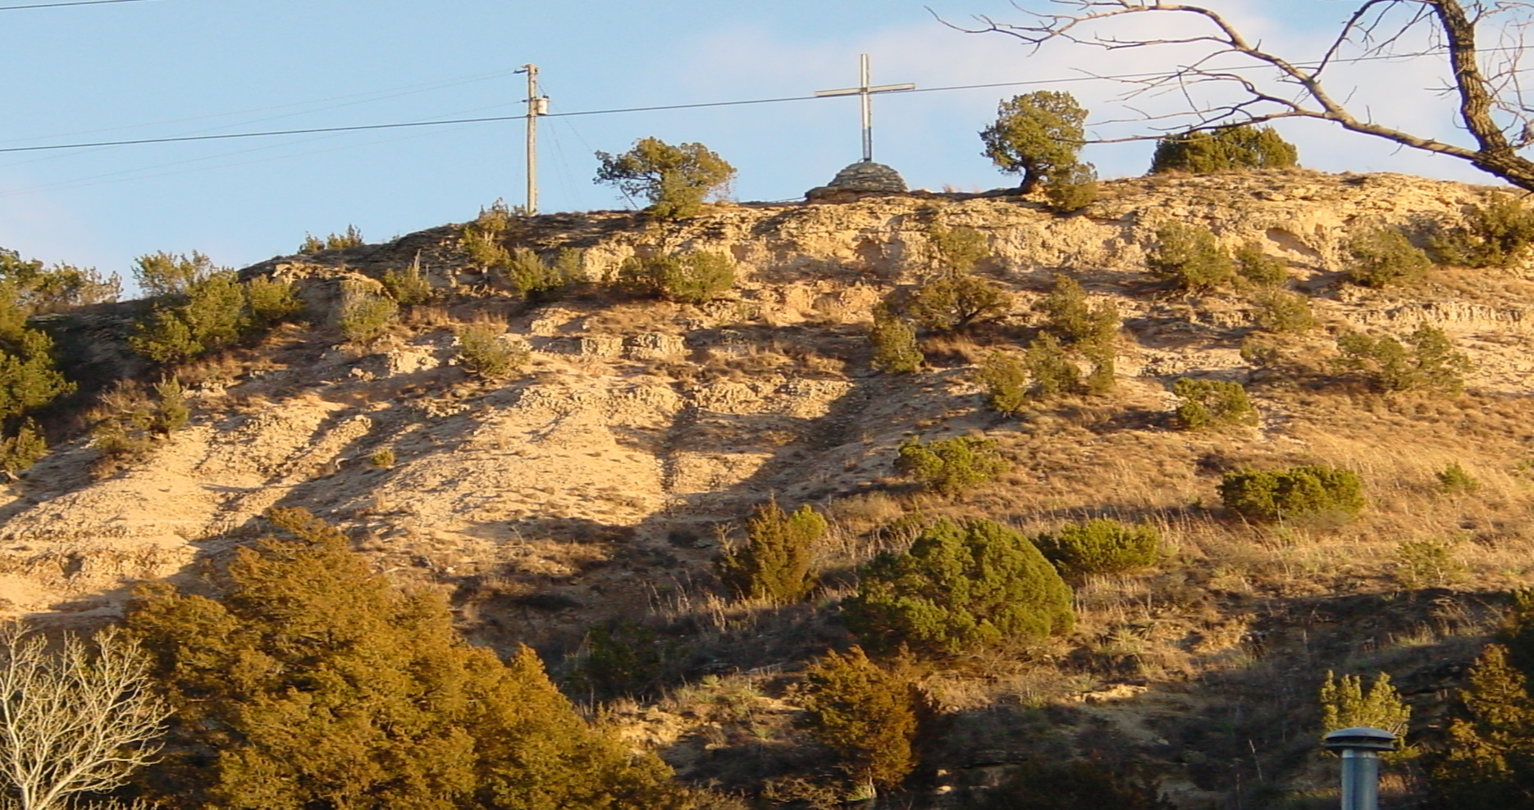

PSPLCA GOLF TOURNAMENT ENTRY FORM

8TH ANNUAL

DATE: Friday, May 2nd, 2025
TIME: Registration at 7:00AM. Shotgun Start at 8:00AM
PLACE: Shadow Hills Golf Course
6002 3rd Street, Lubbock, TX, 79416
806-793-9700

ENTRY FEE: $100.00 (includes: green fees, cart, 3 drink tickets, range balls, door prize ticket and lunch)
$400.00 per team
Payment Due by April 29, 2025.
Send checks to Chris Breunig (address to the left)
Checks need to be made out to PSPLCA
Payment may also be made via the “Eventbrite” web portal

Incentives: $500 cash for first place Team
$400 cash for second place Team
$100 cash for random Team Drawing
Longest drive contest
Closest to the pin contest
Hole in one contest
Funniest team name prize
Prize for last place Team
Basket Raffle Tickets $5 each, 5 for $20
Mulligans, limit 10 per team, 1 for $5, 5 for $20
Gimmie Strings, limit one per person $10 (*Single use string*)

Over $7,000 in cash and prizes given out during the 7th annual tournament. Anticipate a similar amount to be awarded this year!

Format: Tournament will be played in Scramble with 4-person teams.

Team Members & Email Contact Information:

Team Name: _________________________________________________________

Player 1 Name: ______________________________________________________

Email Contact: ________________________________________________________

Player 2 Name: ______________________________________________________

Email Contact: ________________________________________________________

Player 3 Name: ______________________________________________________

Email Contact: ________________________________________________________

Player 4 Name: ______________________________________________________

Email Contact: ________________________________________________________

Golf Committee:
Chris Breunig
Adam Beikman
Austin Ratke
Stephen Drewell

CONTACT:
Chris Breunig
806-781-3052
Stephen Drewell
806-441-0652
Adam Beikman
806-410-8014
Austin Ratke
575-714-3221

* Mailing Address

Chris Breunig
4109 124th St
Lubbock, TX 79423

Send Entry Forms &
Payment to above address.
Checks made out to
PSPLCA

